A.U.R.A. UX FLOW & UI DESIGN MASTER BRIEF
Project Overview
Design a complete enterprise-grade recruitment intelligence platform called:
A.U.R.A.
AI Unified Recruitment Assistant
A.U.R.A. is an AI-powered recruitment intelligence platform designed to help recruiters identify candidate readiness, communication capability, potential, and fit earlier in the hiring process through objective, scalable assessment. It transforms assessment results into hiring intelligence and recruiter decision support. [AURA_Activ...down v.2.1 | Excel], [Voice CAT Rubric | PDF], [CATalyze P...Flowchart | PowerPoint]
Brand Promise
From communication assessment to hiring intelligence.
A.U.R.A. helps recruiters identify readiness, potential, and fit earlier through AI-powered assessment while improving consistency, scalability, and hiring confidence. [AURA_Activ...down v.2.1 | Excel], [Voice CAT Rubric | PDF]

Core Design Principles
Design a minimalist enterprise SaaS experience that feels:
- Intelligent
- Modern
- Objective
- Human-centered
- Trustworthy
- Scalable
- Enterprise-ready
The experience should feel closest to:
- Notion
- Linear
- Stripe
- Grammarly
- Airtable
- Apple Human Interface Design
Avoid:
- Gaming UI
- Consumer app aesthetics
- Excessive gradients
- Decorative AI imagery
- Generic chatbot interfaces
- Visual clutter

Platform Architecture
There are two primary product experiences.
1. Recruiter / Admin Dashboard
Used by:
- Recruiters
- CAT Team
- Hiring Leaders
- Administrators
2. Candidate Assessment Portal
Used by:
- External applicants
- Internal applicants
- Candidates taking voice, written, or role-based assessments

RECRUITER DASHBOARD EXPERIENCE
Create a complete UX flow and high-fidelity UI designs for:
Dashboard Home
Display:
- Total Candidates
- Assessments In Progress
- Assessments Completed
- Recommended Candidates
- Interview Ready Candidates
- Pass Rate
- Average Assessment Score
Include:
- Candidate funnel visualization
- Assessment completion trends
- Recruiter activity feed
- Location-based analytics
- Program-based analytics

Candidate Management
Data table displaying:
- Candidate Name
- Candidate ID
- Program
- Location
- Assessment Type
- Assessment Status
- Readiness Score
- Recommendation Status
- Date Completed
Available Actions:
- View Candidate
- Download Report
- Review Recording
- Add Recruiter Note
- Recommend
- Hold
- Reject
- Export Results

Candidate Results Page
This is the most important recruiter screen.
Display:
Candidate Summary
- Candidate Name
- Candidate ID
- Role Applied For
- Assessment Date
- Status
- Recommendation
Readiness Score
Display an overall readiness score out of 100.
Examples:
- Strong Recommendation
- Recommended
- Consider
- Not Recommended

Assessment Competency Breakdown
Display visual performance cards for:
Voice Assessment
- Pronunciation
- Speech Clarity
- Reading Fluency
- Listening Comprehension
- Vocabulary
- Grammar
- Communication Effectiveness
Behavioral Assessment
- Empathy
- Problem Solving
- Positive Scripting
- Critical Thinking
- Decision Making
Writing Assessment
- Professional Writing
- Grammar
- Coherence
- Tone
- Accuracy

AI Insights Panel
Provide:
- Key Strengths
- Areas for Improvement
- Hiring Recommendation
- Suggested Interview Focus Areas
- Candidate Readiness Summary

Assessment Recording Review
Include:
- Audio Playback
- Transcript
- AI Evaluation Notes
- Competency Highlights

Recruiter Decision Area
Actions:
- Advance to Interview
- Recommend
- Hold
- Reject
- Add Notes

ANALYTICS & REPORTING
Create Enterprise Analytics screens for:
- Assessment Pass Rates
- Candidate Distribution
- Hiring Funnel Performance
- Program Performance
- Location Performance
- Recruiter Efficiency
- Candidate Readiness Trends
- Assessment Effectiveness

CANDIDATE EXPERIENCE
Design a clean, distraction-free, minimalist assessment experience.
Candidate experience should feel:
- Fair
- Calm
- Guided
- Professional
- Stress-free

Candidate UX Flow
Step 1
Login
- Assessment Link
- Candidate ID
- Access Code

Step 2
Welcome Screen
Display:
- Assessment Name
- Estimated Duration
- Assessment Components
- Instructions
- Privacy Notice
Include:
- Microphone Check
- Audio Check
- Webcam Status
- Internet Check

Step 3
Candidate Information
Fields:
- Candidate Name
- Candidate ID
- Location
- Program
- Consent

Step 4
Assessment Experience
Use a single-task layout.
Display only one question at a time.
Show:
- Progress Indicator
- Question
- Instructions
- Timer (if needed)
- Previous / Next Navigation

VOICE ASSESSMENT EXPERIENCE
Design UI screens for:
Sound It Out
Read isolated words aloud.
Measures:
- Pronunciation
- Speech Clarity
Reading Fluency
Read workplace passages aloud.
Measures:
- Fluency
- Pace
- Accuracy
Grammar Challenge
Select and verbally read the correct response.
Measures:
- Grammar
- Vocabulary
Listen and Repeat
Listen to audio and repeat accurately.
Measures:
- Listening
- Pronunciation
- Memory
Comprehension Challenge
Read and listen to scenarios.
Answer comprehension questions.
Measures:
- Listening
- Retention
- Understanding
Respond to the Situation
Candidate chooses and vocalizes an appropriate response.
Measures:
- Empathy
- Problem Solving
- Communication
Storytelling
Candidate shares an experience.
Measures:
- Coherence
- Confidence
- Communication
Opinion Sharing
Candidate provides a structured response.
Measures:
- Critical Thinking
- Organization
- Communication
[AURA_Activ...down v.2.1 | Excel]

WRITTEN ASSESSMENT EXPERIENCE
Design screens for:
Email Comprehension
Review scenario.
Identify:
- Concern
- Action Needed
- Resolution
Email Writing
Create professional email responses.
Chat Simulation
Respond in real time to customer messages.
Accuracy Checking
Validate information against source material.
Grammar Editing
Correct professionalism and language errors.
[AURA_Activ...down v.2.1 | Excel]

ROLE-BASED ASSESSMENT EXPERIENCE
Design future-state screens for:
- Situational Judgment Tests
- Cognitive Assessments
- Behavioral Assessments
- Job Simulations
- Decision-Based Activities
[CATalyze P...Flowchart | PowerPoint]

ASSESSMENT RUBRIC VISUALIZATION
Create scorecard components for:
- Phonological Control
- Lexical Resource
- Grammatical Accuracy
- Interaction & Discourse Management
- Coherence
Support scores:
- 1
- 2
- 3
- 4
Display:
- Performance Level
- Description
- Recommendation
[Voice CAT Rubric | PDF]

REQUIRED DELIVERABLES
Generate:
- Information Architecture
- Complete UX Flow Diagram
- Recruiter Dashboard UX Flow
- Recruiter Dashboard UI Designs
- Candidate Portal UX Flow
- Candidate Voice Assessment Screens
- Candidate Written Assessment Screens
- Candidate Results Experience
- Analytics Dashboard
- Component Library
- Design System
- Desktop Screens
- Tablet Screens
- Mobile Responsive Screens
- Empty States
- Loading States
- Success States
- Error States

Creative Direction
The entire experience should visually communicate:
Opportunity → Assessment → Readiness → Confidence
The product must not feel like a testing platform.
It must feel like a recruitment intelligence platform that transforms candidate potential into confident hiring decisions.

MASTER AI PROMPT
A.U.R.A. UX FLOW + UI DESIGN SYSTEM

Design a complete enterprise-grade recruitment intelligence platform called:
A.U.R.A.
AI Unified Recruitment Assistant
A.U.R.A. is an AI-powered recruitment intelligence platform that helps recruiters identify candidate readiness, communication capability, potential, and fit earlier in the hiring process through objective, scalable assessment.
The platform's purpose is not simply testing candidates.
Its purpose is:
Transforming assessment into hiring intelligence.
The platform evaluates communication, listening, reading, speaking, writing, behavioral judgment, role-based competencies, and professional readiness while helping recruiters make more confident hiring decisions.
The platform should feel:
- Intelligent
- Modern
- Minimal
- Human-centered
- Enterprise-ready
- Objective
- Trustworthy
- Scalable
Avoid:
- Gamification
- Excessive gradients
- Consumer app styling
- Generic AI visuals
- Decorative UI patterns
- ChatGPT clones
The platform should feel closer to:
- Notion
- Linear
- Stripe
- Airtable
- Grammarly
- Workday (but much cleaner)
- Apple Enterprise Design Language

CORE BRAND PROMISE
From communication assessment to hiring intelligence.
A.U.R.A. transforms candidate assessment data into objective hiring intelligence that enables recruiters to identify readiness, potential, and fit earlier and at greater scale.
The emotional outcome should be:
For Recruiters:
- Confidence
- Clarity
- Control
For Candidates:
- Fairness
- Simplicity
- Trust

DESIGN LANGUAGE
Style
Modern Minimalist Enterprise SaaS
Clean white space.
Strong typography.
Subtle Optum orange accents.
Data-forward.
Human-centered.
Avoid visual clutter.

How to think about our color system
Our color system supports three core goals:
- Create calm, readable interfaces using neutrals and warm surfaces
- Express brand through controlled accent and decorative color use
- Communicate meaning through semantic states such as success, warning, info, and danger
Background, middleground, foreground, highlight, and decorative colors
In brand guidance, colors are often described as a primary palette supported by secondary or supporting palettes. While this documentation uses different groupings (background, middleground, foreground, highlight, decorative, plus semantic and interaction), the intent is aligned:
- Core surfaces establish the visual tone and readability of the interface
- Supporting color groups add hierarchy, interaction, and meaning without overwhelming the experience
Design intent:
- Background and middleground colors carry most layouts and surfaces
- Foreground colors carry content and structure
- Highlight draws attention sparingly
- Decorative colors reinforce brand without becoming functional UI signals
At a glance
- Background: White (#FFFFFF)
- Middleground: White (#FFFFFF), Warm White (#FAF8F2)
- Foreground: Warm Gray (#3D3C38) to Ash (#F3F3F3)
- Highlight: Dawn orange (#FFD1AB)
- Decorative: Optum orange (#FF612B), Sky blue (#D9F6FA), Horizon (#EDE8E0), Sunset orange (#F9A667)

Background color
White (#FFFFFF) is the primary background color across Optum products, used for:
- Page backgrounds
- Large layout regions behind scrollable content

Middleground colors
White and Warm White
Middleground colors are the surface layer used for cards, containers, and page sections where subtle elevation and hierarchy are needed.
White (#FFFFFF)
Used for cards and containers where maximum clarity and neutrality are needed.
Warm white (#FAF8F2)
A softer surface color used to introduce subtle warmth and hierarchy without adding visual weight.
It is primarily used for:
- Cards and containers
- Secondary or specialist experiences
- Surfaces where a warmer tone improves comfort and visual separation from primary content
Warm white (#FAF8F2) should be used intentionally and in balance with White (#FFFFFF) surfaces, particularly in flows or pages where a softer visual tone supports focus or reduces cognitive load.
Warm white cards do not require a border color.
Hex: #FAF8F2

Foreground colors
Foreground colors, formerly the neutral ramp, are used for content, borders, dividers, disabled states, and structural UI. These should make up the majority of any interface.
Ash (#F3F3F3)
Disabled button fills
Smoke (#E7E6E4)
Disabled state fills, card borders
Iron (#CECDCA)
Subtle dividers and borders
Slate (#989790)
Disabled text
Oracle (#504F4A)
Input and panel borders
Warm Gray (#3D3C38)
All text and icons
Charade (#232220)
Interaction states (hover)
Black (#000000)
Interaction states (active)

Highlight colors
Dawn Orange
A highlight color used sparingly to draw attention to key UI elements without becoming an “always-on” brand flood.
Typical uses include highlights within components such as tags/chips, avatars, stadia, and supporting graphics or illustrations.
Sunset Orange
- Use sparingly in small UI elements (e.g. tags/chips)
- Do not use for page-width sections or layout formatting
- Primary use is in brand graphics, illustrations, and decorative flourishes
- Used in Progress bar and File Upload component

Decorative colors
Optum Orange, Sky Blue, Horizon, Sunset Orange
Decorative colors reinforce brand and add visual richness, but should not be used to communicate state, priority, or interaction.
Optum Orange
Within the product UI, Optum Orange remains a brand-expression color only. It is reserved for logos, illustrations, brand icons, and decorative brand moments. Its presence can range from strong brand moments to small highlights, but it should not be used as a general UI utility color, for text, or for interactive elements.
Sky Blue
- Use sparingly in small UI elements (e.g. tags/chips)
- Do not use for page-width sections or layout formatting
- Primary use is in brand graphics, illustrations, and decorative flourishes
Sunset Orange
- Use sparingly in small UI elements (e.g. tags/chips)
- Do not use for page-width sections or layout formatting
- Primary use is in brand graphics, illustrations, and decorative flourishes
Horizon
- Can support hierarchy as a background or content block fill. Best suited for secondary or supporting content (e.g. legal, metadata, or low-priority supporting sections)
- Do not use as a full-page or page-width flood
- Always check legibility when pairing with text. Smaller or more condensed text styles, while they may pass WCAG and ACoE guidelines, can still prove difficult to read.

Interaction colors
Links
Standard link styles use Warm Gray with an underline, icon, bold weight, or other affordance where needed.
Standard link: Warm Gray
Standard link hover: Charade
High emphasis link: High Emphasis Link
- Do not use on Warm White
- Do not use on Warm Gray backgrounds.
High emphasis link hover

Component hover fill
Dune
Hover states are used to communicate interactivity and indicate that an element can be acted upon. For consistency across the system, Dune is the standard hover fill for interactive components.
Dune is used as the hover fill for all interactive elements except buttons, which have their own defined hover and active styles.
This ensures a predictable and recognisable hover signal across the interface without competing with button emphasis or semantic states.
Where to use Dune hover fill
Use as the hover fill for:
- Input fields
- Dropdowns and select menus
- Menu items and list items
- Checkboxes, radio buttons, and toggles (where a hover surface is present)
- Clickable rows or cells
- Other non-button interactive elements
Dune provides a subtle, warm hover indication that works consistently across both White and Warm White surfaces.
Where not to use Dune hover fill
Do not use as a hover fill for:
- Elements with semantic hover states
- Elements where hover is communicated through other means (e.g. underline, icon change, elevation)
Buttons follow their own interaction colour rules and must not inherit the generic component hover fill.
Text and icon pairing
When using Dune as a hover fill:
- Pair with Warm Gray text and icons
This pairing maintains legibility and visual consistency across all hoverable components.
Behavioural guidance
- Hover fills must not replace or suppress focus states
- Hover styles should reinforce interactivity without increasing visual weight or hierarchy
- Dune should be applied consistently across components to avoid fragmented hover behaviour

Button interaction colours
Button interaction colours are a restricted set of colours reserved exclusively for buttons. These colours are used to communicate action, hierarchy, and emphasis through fill, border, and text treatments.
Button interaction colours must not be reused for non-interactive elements.
Dark Orange
Dark orange is the primary vibrant button colour and represents the strongest brand-aligned call to action.
Used for:
- Filled vibrant button: rest fill and border
- Outline vibrant button: rest border, text, and icons
Accessibility:
- Always pair with White text and icons when used as a filled button.
- Do not use Dark Orange outside of button interactions.
Persimmon
Persimmon provides a stronger interaction signal for vibrant buttons without escalating to the deepest destructive or brand tones.
Used for:
- Filled vibrant button: hover fill and border
- Outline vibrant button: hover border, text, and icons
Accessibility:
- When used on light fills, ensure sufficient contrast with text and icons.
Brick
Brick is the deepest vibrant orange used for active states and reinforced emphasis.
Used for:
- Filled vibrant button: active fill and border
- Outline vibrant button: active border, text, and icons.
Porcelain
Porcelain is a very light surface colour used to provide subtle hover feedback for outlined vibrant buttons.
Used for:
- Outline vibrant button: hover fill
Accessibility:
- Pairs with Persimmon for text and icons.
Peach
Peach provides a slightly stronger surface fill for outlined vibrant buttons during active interaction.
Used for:
- Outline vibrant button: active fill
Accessibility:
- Pair with Brick for text and icons.
Warm Gray
Warm Gray is the foundation colour for neutral buttons, providing a calm, non-brand-dominant action style.
Used for:
- Filled neutral button: rest fill and border
- Outline neutral button: rest border, text, and icons
- Ghost button: rest text and icons
Accessibility:
- Always use White text and icons when used as a filled button.
Charade
Charade is the primary hover colour for neutral and low-emphasis buttons.
Used for:
- Filled neutral button: hover fill and border.
- Outline neutral button: hover border, text, and icons.
- Ghost button: hover text and icons.
Black
Black represents the strongest neutral interaction state and is reserved for active states.
Used for:
- Filled neutral button: active fill and border.
- Outline neutral button: active border, text, and icons.
- Ghost button: active text and icons.
White
White is used exclusively as a high-contrast foreground colour in button interactions.
Used for:
- Filled vibrant buttons: text and icons (all states).
- Filled neutral buttons: text and icons (all states).
- Destructive button: active text and icons.
Dune
Dune provides a subtle hover surface for low-emphasis button interactions.
Used for:
- Ghost button: hover fill.
Horizon
Horizon is used as a low-contrast surface fill for non-prominent active states.
Used for:
- Ghost button: active fill.
Destructive button colors (semantic-derived)
Destructive buttons use a dedicated subset of colors derived from the semantic danger palette. These colors are named by visual strength, not interaction state, and are intended for destructive buttons only.
Destructive LIGHT
Used for:
- Destructive button: rest fill.
Destructive MEDIUM
Used for:
- Destructive button: hover fill
Destructive DARK
Used for:
- Destructive button: active fill.
- Destructive button: border colour (rest and hover states).
Accessibility:
- Use White text and icons when used as a filled surface.

Semantic colors
Semantic colors communicate system status and feedback.
Light variants are used for backgrounds; dark variants are used for borders, icons, and emphasis.
Success
Used for successful completion and stable “good” states.
- Use Dark Success for icons and borders
- Use Light Success for larger message backgrounds and banners.
Pair with Warm Gray text
Warning
Used for caution and intermediate states.
- Use Dark Warning only for icons, borders, and small elements.
- Never use Dark Warning for body text
- Use Light Warning for larger message backgrounds and banners.
- Pair with Warm Gray text
Information
Used for helpful or neutral system messages.
- Use Info Dark for icons, borders, and small elements.
- Use Info Light (#DFF3F9) for larger message backgrounds and banners
- Pair with Warm Gray text
Danger
Used for errors and destructive actions.
- Use Danger Dark for icons, borders, and small elements only.
- Pair with White text on Danger Dark.
- Use Danger Light for larger message backgrounds and banners.
- Pair with Warm Gray text on Danger Light.

Data Visualization
Data visualization is the graphical representation of information and data. It uses visual elements such as tables, charts, graphs, and maps, etc. Data visualization tools provide an accessible way to view and understand trends, outliers, and patterns in data. It enables data to be easily presented to audiences who might not be as familiar with data and analytics.﻿
Categorical palette
Categorical (or qualitative) palettes are best when you want to distinguish discrete categories of data that do not have an inherent correlation. Categorical colors must be displayed in sequence and contrast with one another. The maximum amount of colors is 5 and they must have different hues and saturation levels. For more information on data visualization color usage see the Data Visualization pages on this site.
Color contrast
We are committed to embracing the Web Content Accessibility Guidelines AA standard contrast ratios of a minimum contrast ratio of 4.5:1 (AA and higher). To ensure we meet these contrast ratios, choose colors that support usability by ensuring sufficient color contrast between elements so that they can be recognized by all users.
Usage guidelines
General recommendations
- To bring attention to important events, use stronger color contrasts between elements
- Ensure that interactive areas and state changes remain identifiable and easily seen
- State changes can subtly reinforce brand presence
- Color should be used consistently within each brand
Background colors
The background color appears behind scrollable content to help give sections on a page differentiation. The baseline background and surface colors are White and Warm White.
Colors with typography
To ensure we meet and exceed these minimum contrast ratios:
- Use Warm gray (primary 100)--#3D3C38 for all text.
- Use Slate (neutral 50) -- #929496 for disabled text and icons on Ash (neutral 10) -- F3F3F3 background
Semantic colors
Semantic colors are meant to communicate purpose by helping users convey messages. For example, green has a positive connotation, so it is often used to convey success, confirmation messages, etc. Design Standard's semantic colors should not have their usage meanings changed, nor should the dark colors be used for background colors.
The feedback states are:
- Success Green: used to show positive feedback or status
- Warning Yellow: used to show warning feedback or status
- Danger Red: used to show negative feedback or status
- Info Blue: used to show a neutral message
Interactive elements
Interactive elements use a combination of primary and secondary colors within the UI for the best user experience. It is important to ensure that CTAs and links meet the minimum contrast ratio of 4.5:1 for every state.
For additional information, see the button and link components.
Do's and don'ts
Do
- Do use background colors that support a brand's color proportions.
- Do follow the color contrast ratio recommendations from text to ensure it is legible against background colors.
- Do use the designated semantic colors to display a message to a user.
Don't
- Do not use colors not meant for background usage.
- Do not use background colors with text that doesn't meet the color contrast ratio recommendation.
- Do not use colors that are not designated for semantic usage.

Accessibility
General
Color and contrast choices within a digital experience are accessible when people can:
- Understand color, shape, size, visual location and orientation through equivalent information provided in text or programmatically
- See and interact with UI elements and content because of sufficient contrast
Our aim is to provide an accessible experience by ensuring a contrast ratio that can be perceived by all users. For this reason, we have embraced a minimum contrast ratio of 4.5:1 (foreground vs background) for UI elements and content that conveys meaning and avoid the use color alone.
For more information about color and accessibility, visit our accessibility foundations.
Color Contrast Grid
The colour contrast grid is a QA reference confirming which colour combinations meet accessibility standards.
Compliance does not equal suitability. Designers must continue to follow approved colour pairings, semantic roles, and design system guidance. Use this grid to validate decisions—not to create new combinations.
- Color Contrast Grid (opens in a new tab)

Typography
Use: Arial
Typography hierarchy should resemble: Apple + Notion + Stripe

Icons
Overview
Design Standards leverages material design icons, giving icons a symmetrical and consistent look while ensuring readability and clarity, even at small sizes.
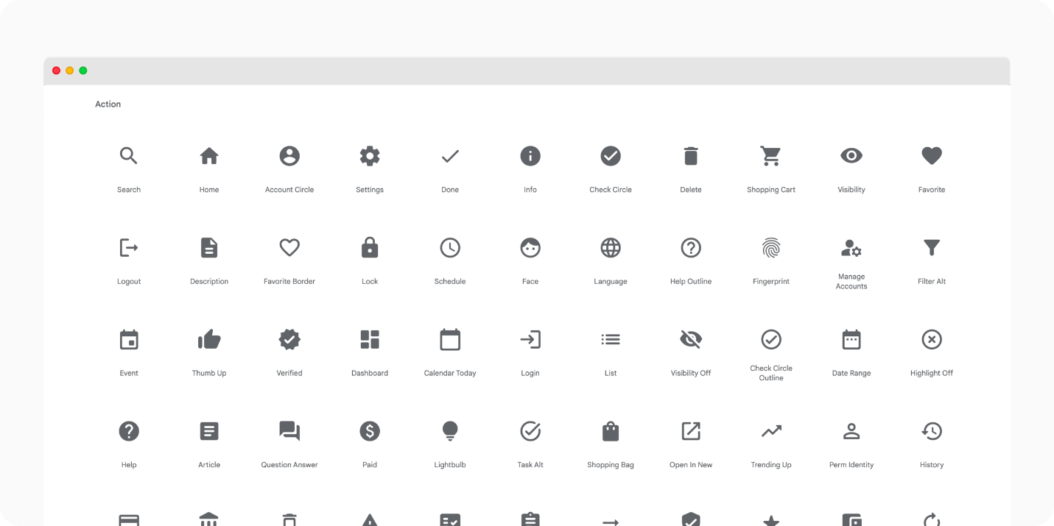

Designer
Connect to our Figma icon library to add icons to your existing libraries and when using Design Standards brand theme libraries.
Icon kit
Developer
Material icons are free for everyone to use. Learn how to integrate icon fonts with your projects.
Material icons font
Characteristics
Experiences can often have complex systems, so to help, icon relationships are clear and additive. The icons help depict tools and topics as simply and precisely as possible. Design Standards adopts existing meanings whenever possible to maintain consistency across experiences and help avoid confusion for our users. The icons and their meanings do not change based on an operating system, with the exception of specific icons that follow platform standards, such as the 'share' icon.
For more information on icon usage and placement, see the usage guidelines.
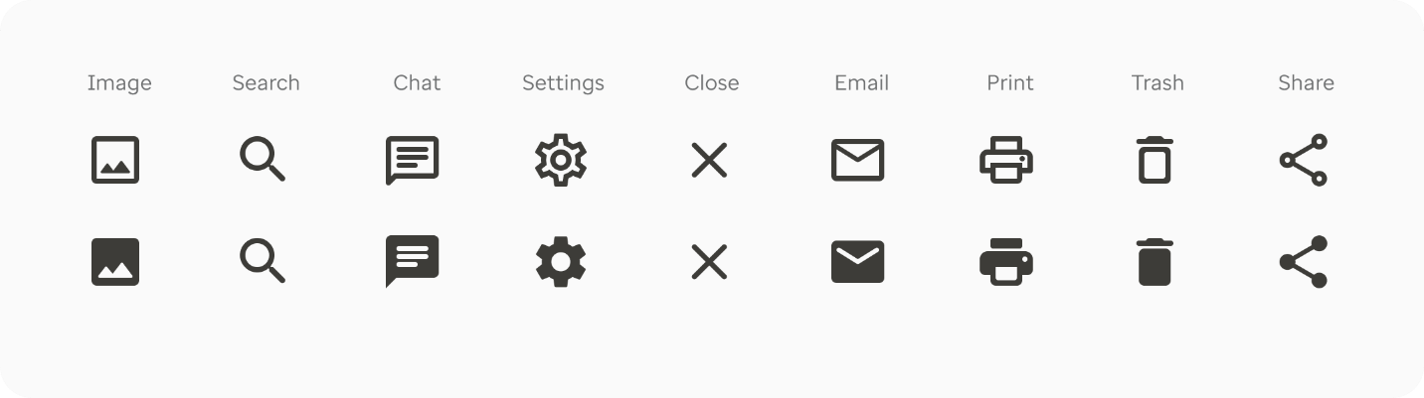
Characteristics
Icons are available in outline and filled versions when appropriate.

Sizing
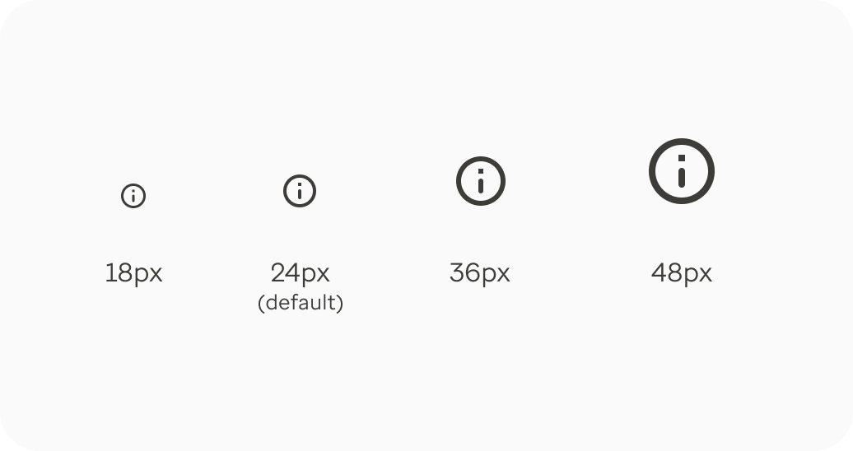
Utility icons are displayed at 24 x 24px by default. Icons can also be used at 18, 36 and 48px within the components based on the size ratio it is paired with (ie. button text, links, navigation, etc). 36 or 48px should only be used for special statements.

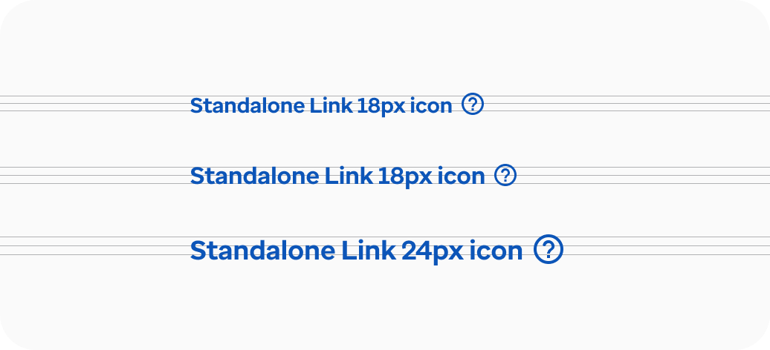
The 18 and 24px icons are optimized to feel balanced when paired with specific font sizes used within our brand themes.

For sizing within a component, please see the guidelines for the specific component.

Layout and keylines
Layout
The icon content should always remain inside the live area of an icon. The live area is the region of an image that is unlikely to be hidden from view, such as when sidebars appear on scroll.
The space between the live and trim area (the complete size of a graphic) is the padding. No part of the icon should extend outside of the trim area. If additional visual weight is needed, content may extend into the trim area based on the usage within an element or component.
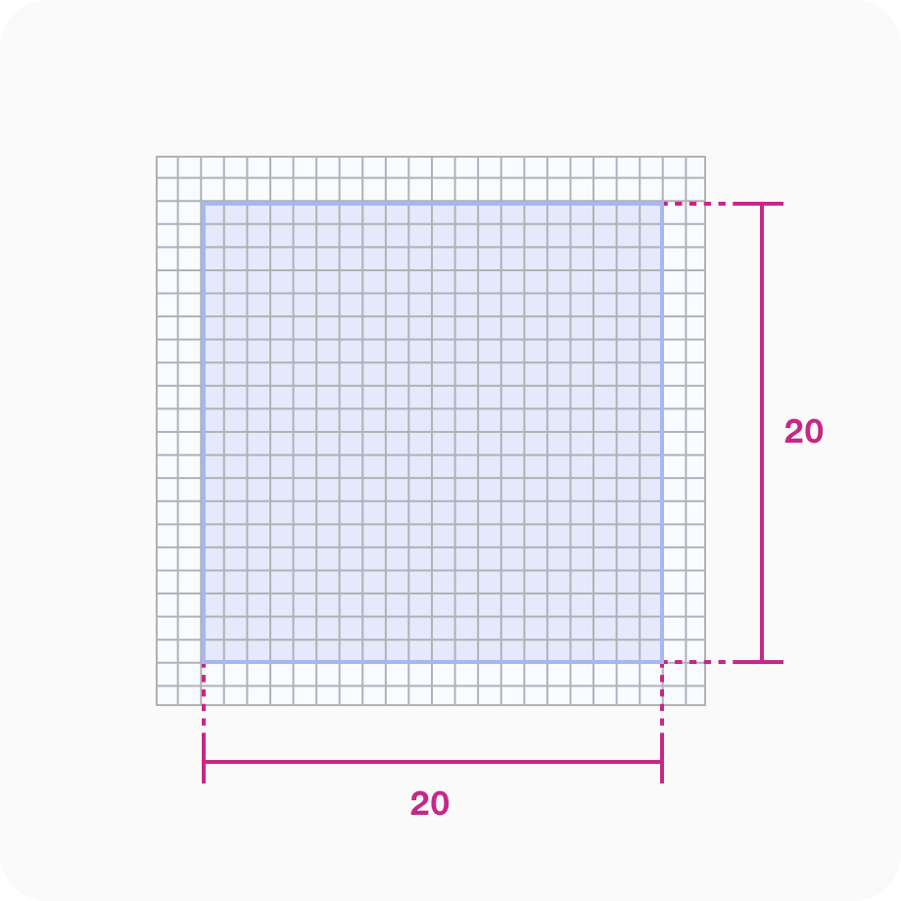
Live Area
Icon content is limited to the 20 x 20px live area with a 2px of lading around the perimeter.

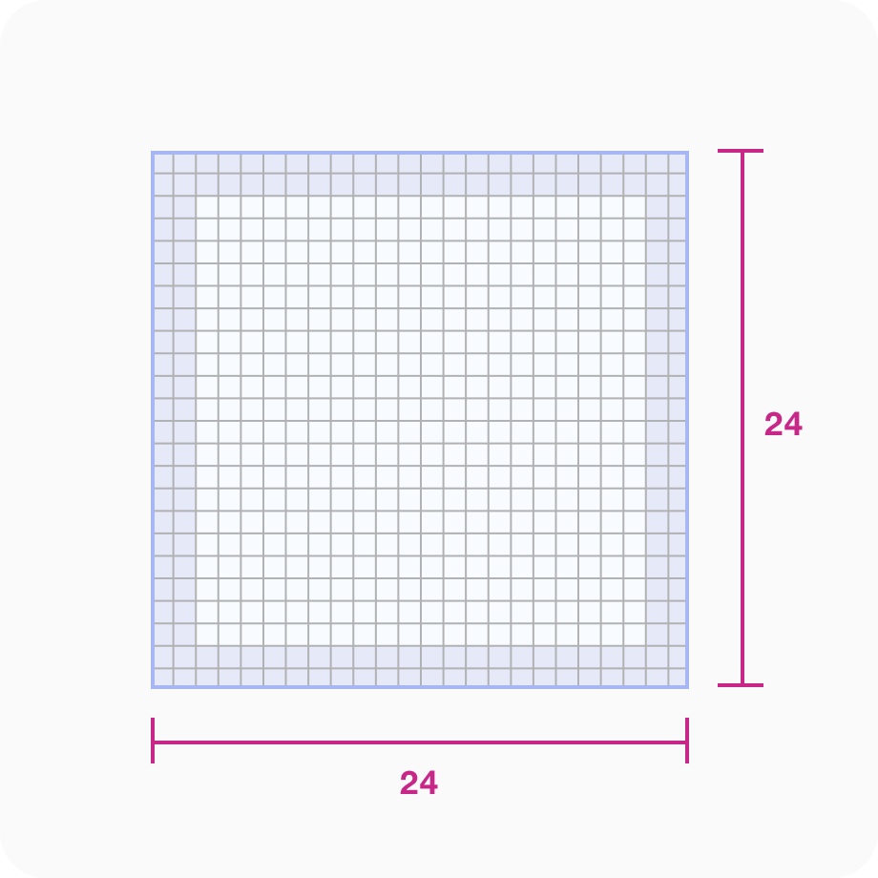
Padding
2px of padding surrounds the live area.

Keyline shapes
Icon grid and keyline
The icon grid establishes clear rules for the consistent, but flexible, positioning of graphic elements. Keyline shapes are the foundation of the grid. By using core shapes as guidelines, we can maintain consistent visual proportions across system icons.
Icon Grid: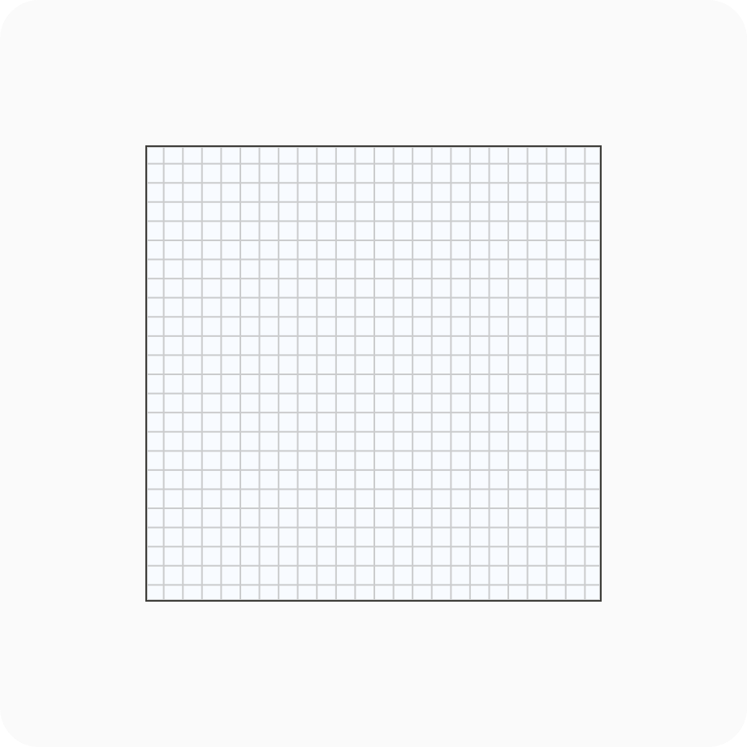

Keylines:
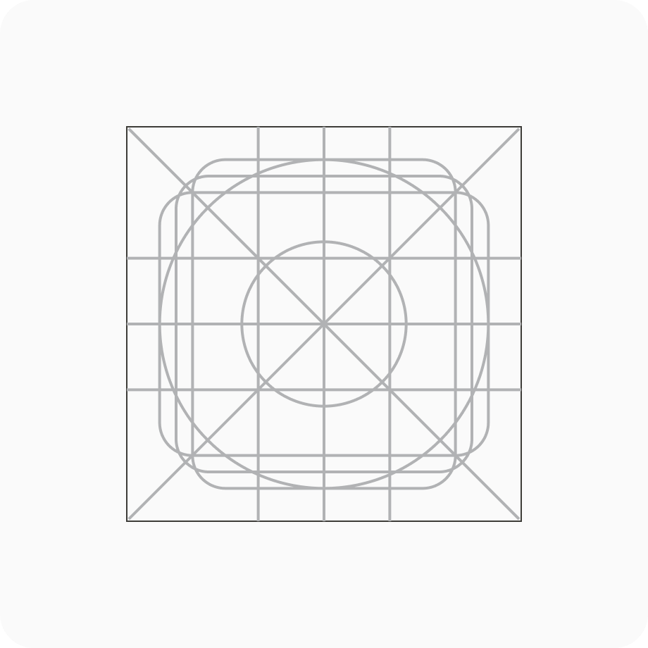

Shapes
Icons are created on the grid using basic foundational shapes: circle, square, vertical rectangle and horizontal rectangle. Adhering to these shapes ensures consistent proportionality of iconography throughout.

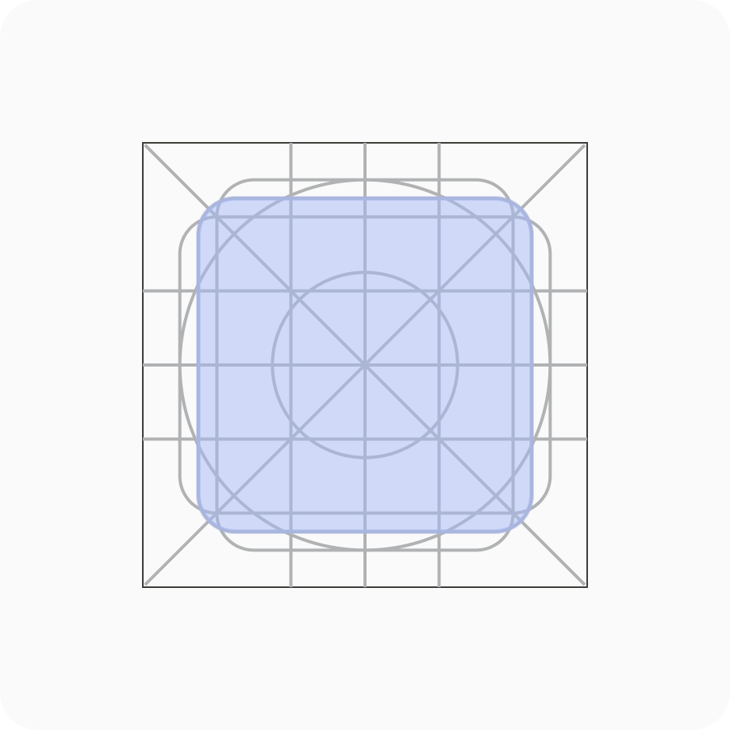
Square
Height - 18px
Width - 18p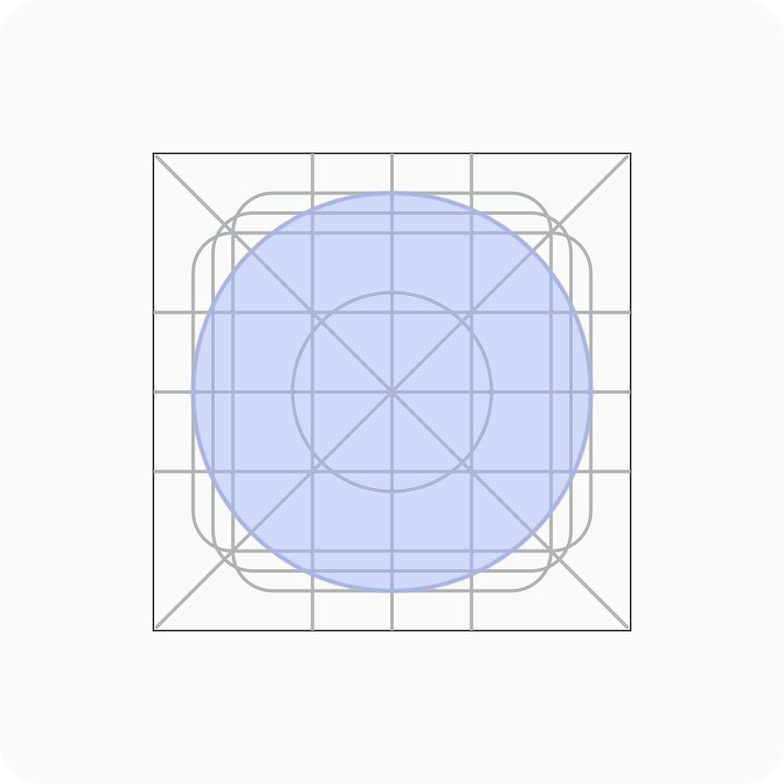
Circle
Diameter - 20px

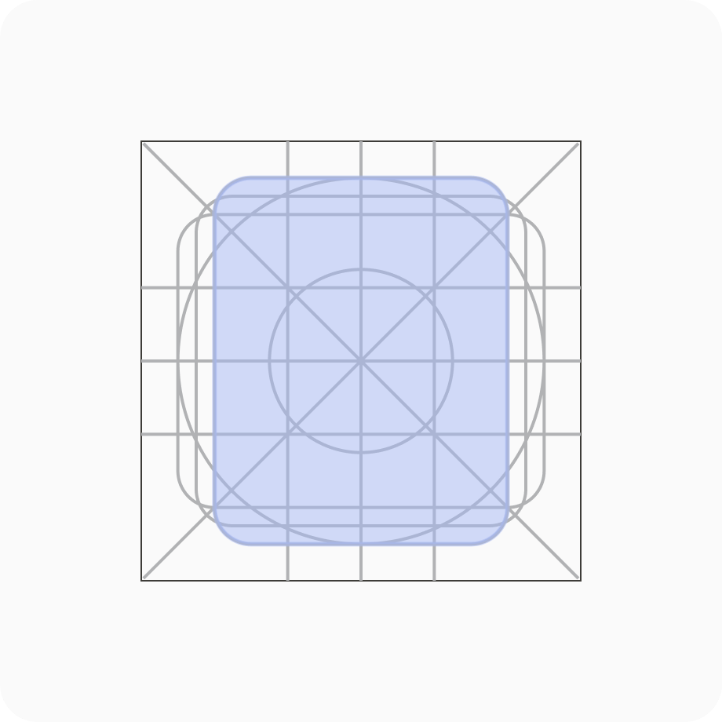
Vertical rectangle
Height - 20px
Width - 16px

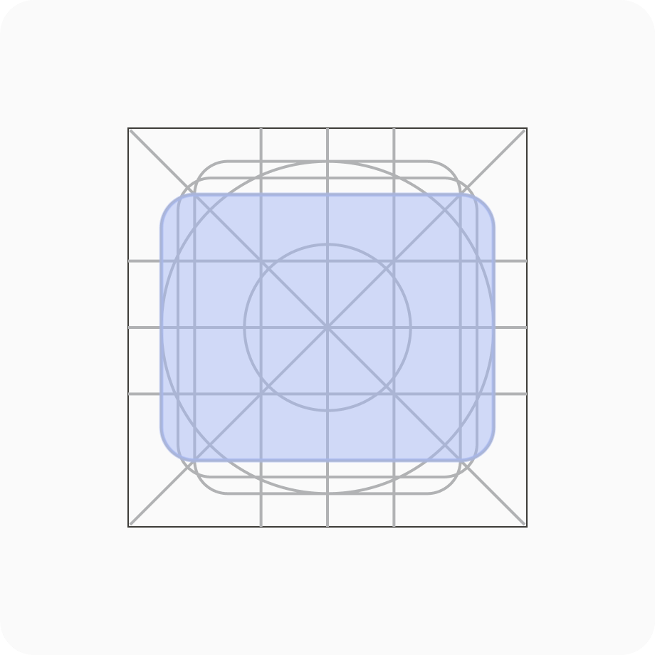

Horizontal rectangle
Height - 16px
Width - 20px

Themes and categories
We use the material design rounded icon theme within the design systems. Rounded icons use a corner radius that pairs well with our corner radius' style.
Figma library kit
The following categories are available: action, alert, audiovisual, communication, content, device, editor, file, hardware, image, map, navigation, notification, places, social, search and toggle. Each icon is assigned to a specific category.
Rounded Icon: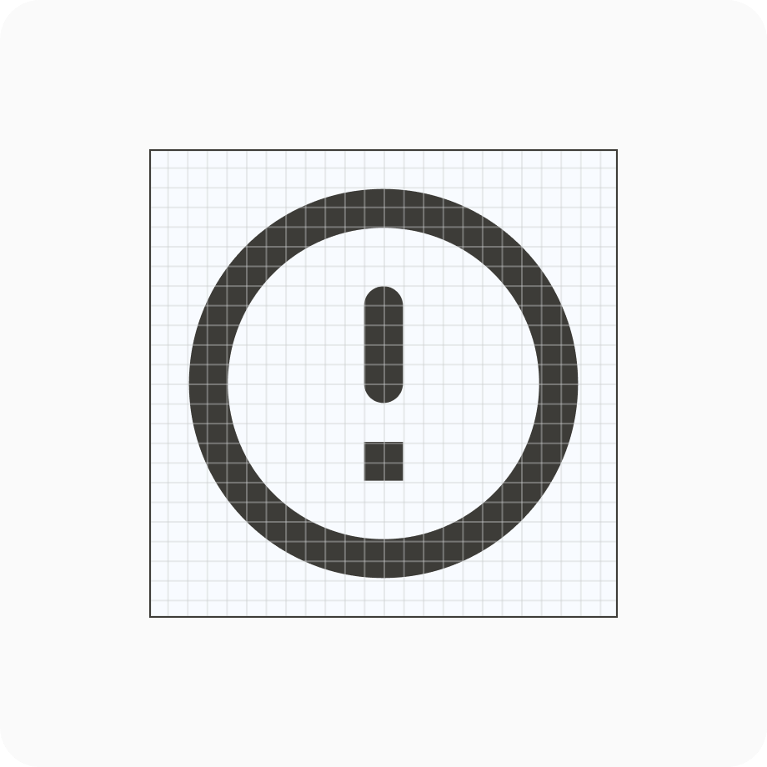
If an icon is required outside this system, please reach out to our team for design direction.

Color
Utility icons are always a solid, monochromatic color that needs to pass the same color contrast ratio as typography (WCAG 2.1 AA, 4.5:1). The utility icon color should reflect the action or inherit the color of what it is paired with.

Usage guidelines
Recommendations
- By default, icons are 24px and can be scaled larger or smaller based on use
- When appropriate, maintain a minimum touch target of 48px
- A minimum of 4px spacing is used (with a default of 8px) when placed next to a label or text
- When used next to text on the left or right, icons should be center-aligned
When to use
- To add simple visual context
- To clarify the purpose and support the meaning of a label or draw attention to a commonly understood action
- With text so the context is accessible to everyone across languages
When not to use
- Avoid using icons in isolation or without labels, unless universally recognized by users (Search, Home, Close, Print)
- Avoid using icons for the sake of it
- Avoid using for general visual context
Placement
To promote consistency for our users and across product lines, we recommend the placement of utility icons in three ways:
- Visual context
- Actions and tasks
- Directional
Visual context placement
For toolbars, navigation, menus and notifications, utility icons are used to provide a visual cue to help the user quickly scan and navigate. Choose an icon that's the most intuitive or directly related to the use case.
Menu:
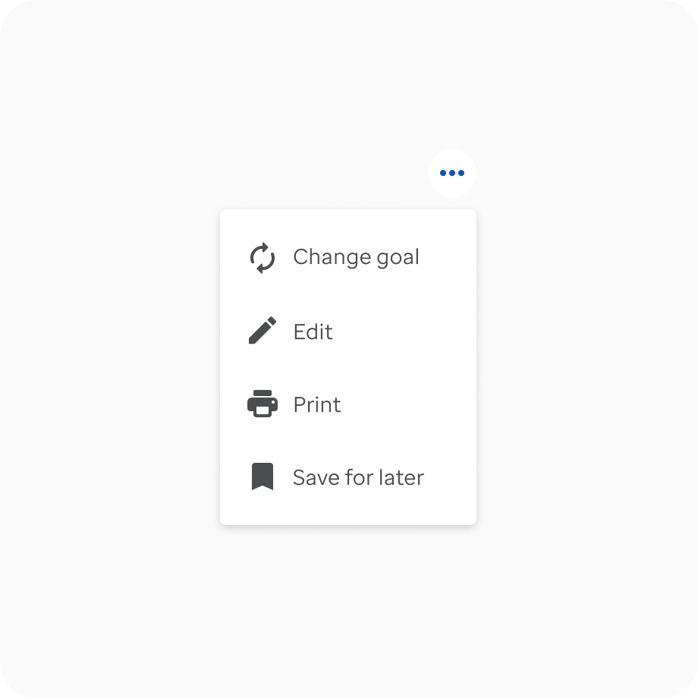
Notification:
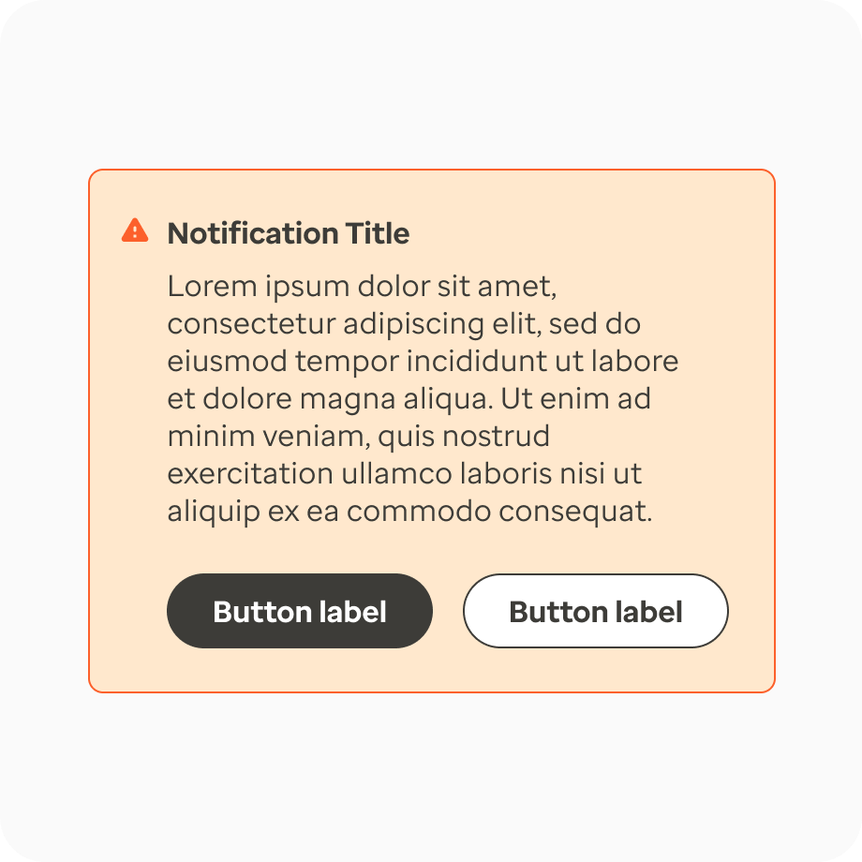

Action and task placement
When users are asked to complete an action or task, utility icons can be used to enhance the experience. They can be used for a radio button, as a stand-alone icon for a popup tip, a close indicator in a modal or within a button or link to support the label or indicate an external link.

Button
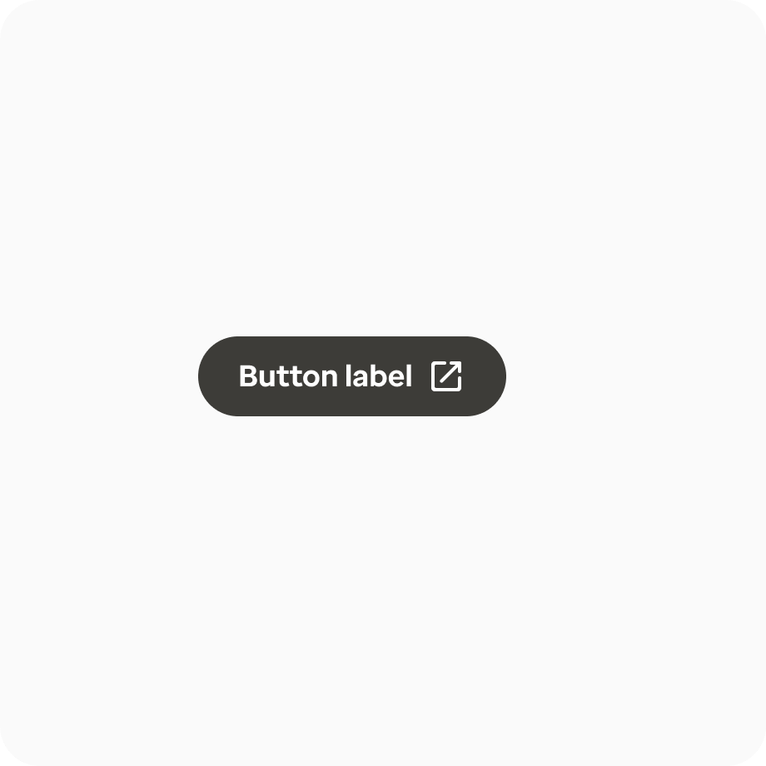
Popups
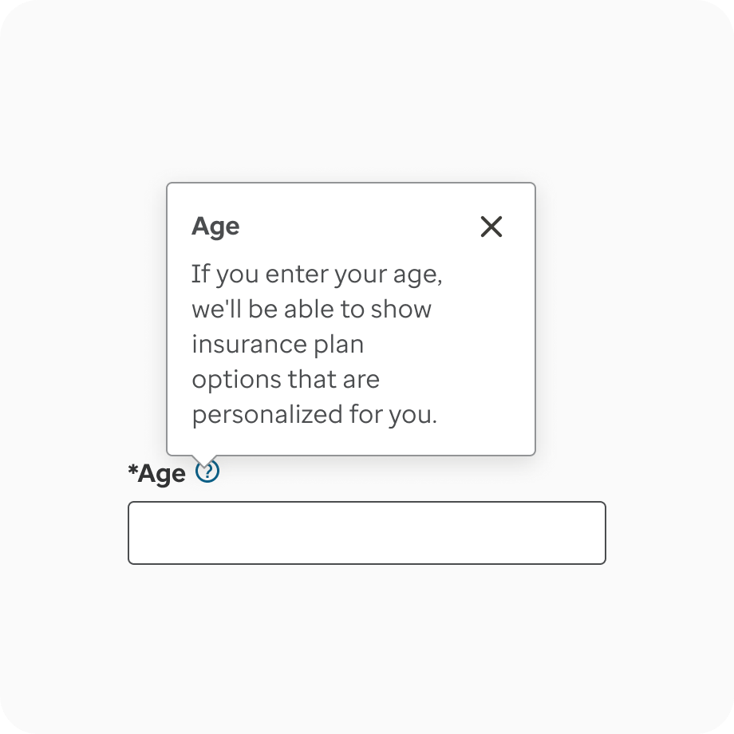

Modal
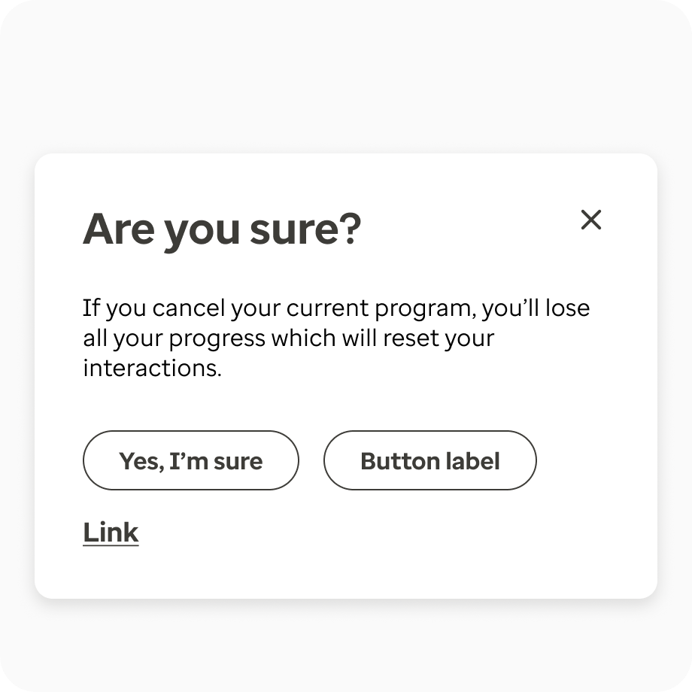

Directional placement
When there is a sequence within an experience, utility icons can help indicate the previous or next step. A good example is within the step tracker component or pagination component. They can also be used to indicate selection lists and expand to view more content such as in the select input or accordion component.

Pagination:
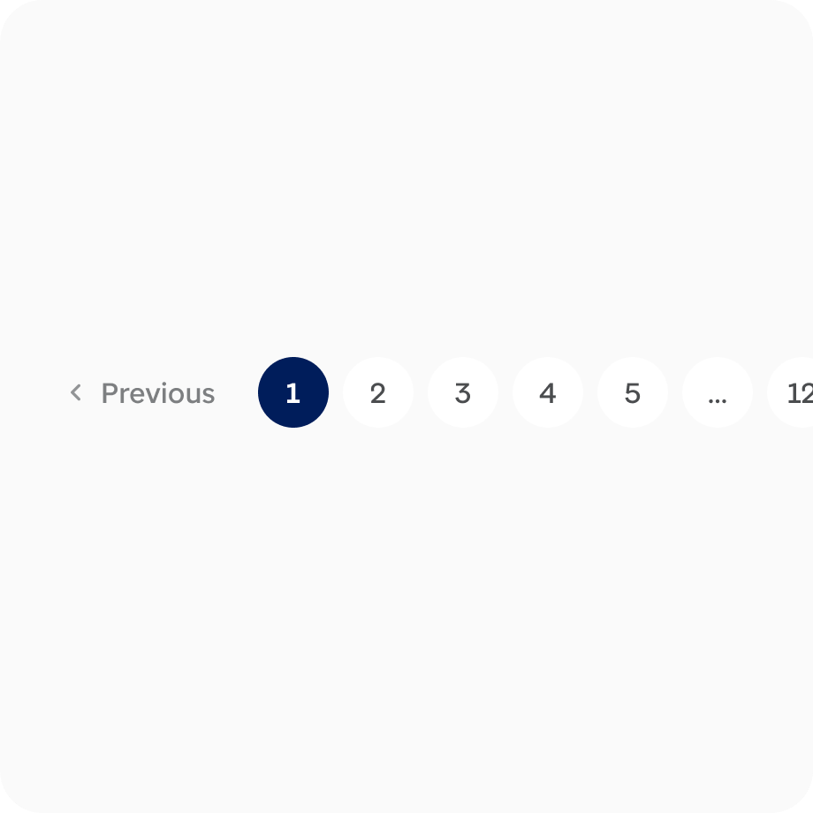
Step Tracker:
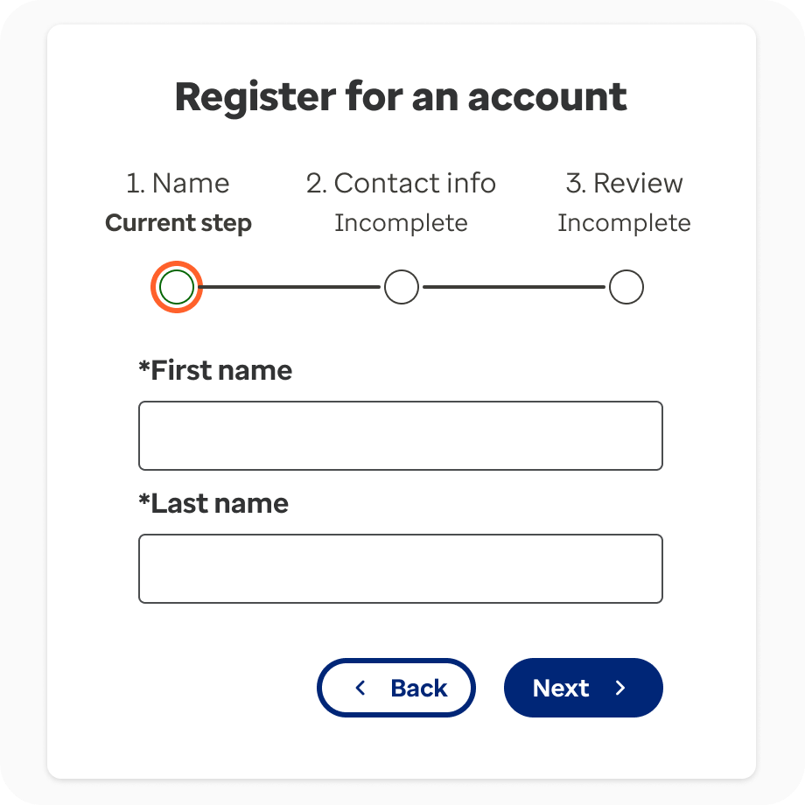

Accordion:
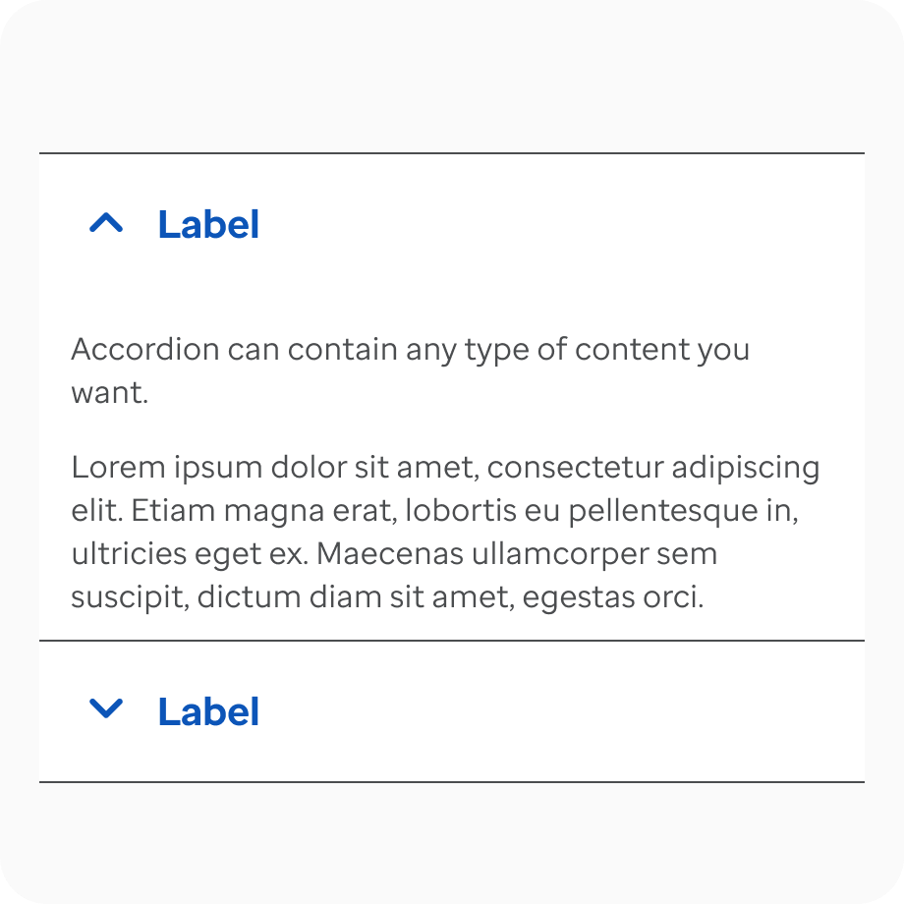

Select Input:
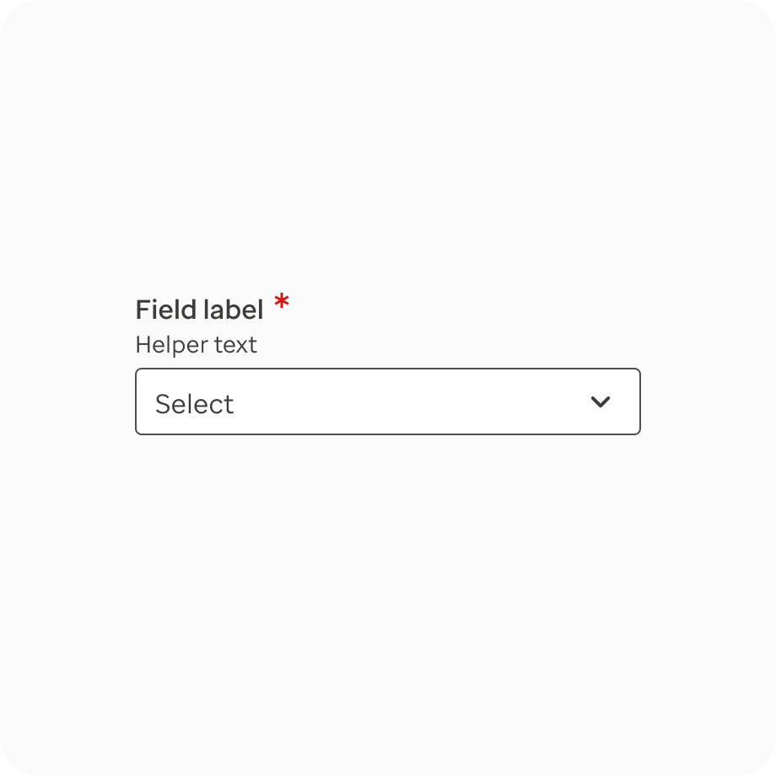

Accessibility
General
When the icon should be visible to screen readers, please fill out the title and description with relevant content to ensure that it is helpful to non-sighted users. If the icon is duplicative and only visually reinforcing text content, do not add the title or description. This will ensure it is hidden from screen readers.
Text alternatives
When the icon conveys meaning, include an appropriate title and description to ensure that people using assistive technology can understand the context of the icon. If the icon is decorative and only visually reinforcing text content, do not add the title or description. This will ensure it is hidden from screen readers.
Resources & Articles
- Material design icons
- Icon kit
- Material icons font
- Icon usage guidelines

TWO MAJOR PLATFORM EXPERIENCES
Design both complete experiences:
1. Recruiter / Admin Dashboard
2. Candidate Assessment Portal

UX FLOW 01
RECRUITER DASHBOARD EXPERIENCE
Primary users:
- Recruiters
- CAT Team
- Hiring Leaders
- Administrators

Dashboard Landing Page
Show:
Header
A.U.R.A. Logo
Global Search
Notifications
Recruiter Profile

KPI Cards
Total Assessments
Candidates In Progress
Completed Assessments
Recommended Candidates
Pass Rate
Average Assessment Score

Assessment Funnel
Visual hiring funnel:
Applicants ↓ Assessment Started ↓ Assessment Completed ↓ Recommended ↓ Interview Ready ↓ Hired

Candidate Distribution
Charts:
Scores by Location
Scores by Hiring Program
CEFR Distribution
Assessment Type Distribution

Recent Activity Feed
Real-time updates:
- Candidate Completed Assessment
- High Scoring Candidate Identified
- Recruiter Review Completed
- Assessment Invitation Sent

Candidate Management Page
Table View
Columns:
Candidate Name
Application ID
Program
Location
Assessment Type
Assessment Status
Readiness Score
Recommendation
Date Completed
Actions

Actions:
View Results
Download Report
Notes
Export
Schedule Interview
Recommend
Reject

Candidate Profile View
This is the most important recruiter screen.
Provide:
Candidate Snapshot
Photo Placeholder
Name
ID
Applied Role
Location
Assessment Date
Status

Readiness Score
Prominent Score Card
Example:
83 / 100
Interpretation:
Strong Recommendation

Communication Breakdown
Radar Chart
Scores for:
Speaking
Listening
Reading
Writing
Vocabulary
Grammar
Pronunciation
Empathy
Professional Communication
Problem Solving

AI Insights Section
Why candidate received current score
Strengths
Areas for development
Recommended next action
Interview focus areas
Suggested coaching points

Assessment Recording Playback
Speaking recordings
Audio player
Transcript
AI feedback

Recruiter Decision Section
Recommend
Proceed to Interview
Hold
Reject
Add Notes

Assessment Administration
Create Assessment
Assign Assessments
Bulk Upload Candidates
Assessment Configuration
Role-Based Templates
Communication Assessment
Written Assessment
SJT Assessment
Behavioral Assessment
Future Assessments

Analytics Dashboard
Executive reporting
Trend analysis
Pass rates
Program performance
Hiring effectiveness
Assessment effectiveness
Recruiter efficiency
Bias monitoring
Readiness distribution
Location-based insights

UX FLOW 02
CANDIDATE EXPERIENCE
Core principle:
Reduce anxiety.
Minimize friction.
Create focus.
This experience should feel like:
Apple onboarding + Duolingo simplicity + Pearson assessment professionalism.

Candidate Journey
Step 1
Login
Invitation Code
Email Verification
Simple minimal screen

Step 2
Welcome Screen
Show:
Assessment Name
Estimated Duration
Assessment Components
Instructions
Microphone Check
Speaker Check
Internet Check
System Readiness
Begin Assessment

Step 3
Candidate Information
First Name
Last Name
Candidate ID
Location
Program
Acknowledgement
Privacy Notice
Continue

Step 4
Assessment Experience
Single-task focus.
No distractions.
One question at a time.
Clear progress tracking.
Large readable content.
Timer only when required.

Assessment Types
Based on A.U.R.A. Requirements
Voice Assessment
Written Assessment
Role-Based Assessment

VOICE ASSESSMENT FLOW
Support:
Reading
Listening
Speaking
Pronunciation
Vocabulary
Grammar
Comprehension
Situational Responses
Storytelling

Activities include:
Sound It Out
Reading Fluency
Grammar Challenge
Listen and Repeat
Comprehension Challenge
Respond to the Situation
Storytelling
Opinion Sharing
Based on documented A.U.R.A. assessments. [AURA_Activ...down v.2.1 | Excel], [AURA_Activ...down v.2.1 | Excel]

For each voice activity:
Display:
Question
Instructions
Audio Controls
Recording Button
Retry Rules
Progress Bar
Next

WRITTEN ASSESSMENT FLOW
Support:
Email Writing
Chat Simulation
Response Editing
Grammar Correction
Information Accuracy
Scenario Writing
Professional Communication
Based on assessment breakdown documents. [AURA_Activ...down v.2.1 | Excel]

UI Components
Scenario Panel
Writing Editor
Character Count
Spell Check Indicator
Timer
Save Draft
Next

ROLE-BASED ASSESSMENT FLOW
Future-state design.
Support:
Situational Judgment Tests
Cognitive Evaluations
Behavioral Assessments
Job Simulations
Decision-based Scenarios

ASSESSMENT COMPLETION SCREEN
Show:
Assessment Completed
Submission Confirmation
Thank You Message
Submission Reference Number
Expected Review Timeline
Progress Successfully Recorded

AI SCORING ARCHITECTURE
Design visual scorecards for:
Phonological Control
Lexical Resource
Grammar
Interaction & Discourse
Coherence
Based on rubric. [Voice CAT Rubric | PDF]

Use:
Score 1–4
Color Scale
Explanation
Behavioral Interpretation
Recruiter Insights

GLOBAL DESIGN PRINCIPLES
Every screen should reinforce:
Opportunity → Assessment → Readiness → Confidence
The interface should visually communicate:
Many candidate signals ↓ AI intelligence ↓ Objective evaluation ↓ Hiring confidence
Use subtle visual motifs inspired by the approved A.U.R.A. logo direction:
Assessment Signals Converging Into Intelligence
Avoid direct waveform graphics.
Instead employ:
- Structured spacing
- Progressive disclosure
- Signal-to-insight hierarchy
- Intelligent use of dots, indicators, and progression markers

REQUIRED OUTPUT
Generate:
- Complete Information Architecture
- End-to-End UX Flow Diagram
- Recruiter Dashboard Wireframes
- Recruiter Dashboard High Fidelity UI
- Candidate Assessment UX Flow
- Candidate Voice Assessment Screens
- Candidate Written Assessment Screens
- Candidate Completion Journey
- Candidate Result Submission Flow
- Candidate Profile & Recruiter Review Experience
- Analytics Dashboard
- Design System
- Responsive Desktop Views
- Responsive Tablet Views
- UI Components Library
- Empty States
- Loading States
- Success States
- Error States
- Accessibility Considerations
Design everything as a modern enterprise product launching in 2026.
The final result should feel like "the Grammarly + Workday + Linear of recruitment assessment intelligence."

Creative Director Challenge
Do not design merely an assessment platform.
Design a system that makes recruiters feel confident in their decisions and candidates feel they were evaluated fairly.
The product is not about testing.
The product is about transforming potential into opportunity through intelligence.

